*Case study 8.2:* ***Futility of tuning based on 1 extreme meal*** V.2

Below a detailed application example is given for using the emulator to fine-tune autoISF parameters.

Key learning: It turned out a mistake to tinker more with a loop that already had been well tuned for months, to adjust it „better“ to data from just one day.

Glucose data from a „bad day“ for logfile analysis

Frustrated about an extremely bad day, after a month with over 90% TIR, the logfiles of this day were analyzed.

The first assumption was that higher peaks than usual resulted because perhaps CGM values arrived late, or were released late by the built-in quality assurance. However, with one isolated exception (18.12 UTZ in table below), there was no problem that could be attributed to CGM "delays".

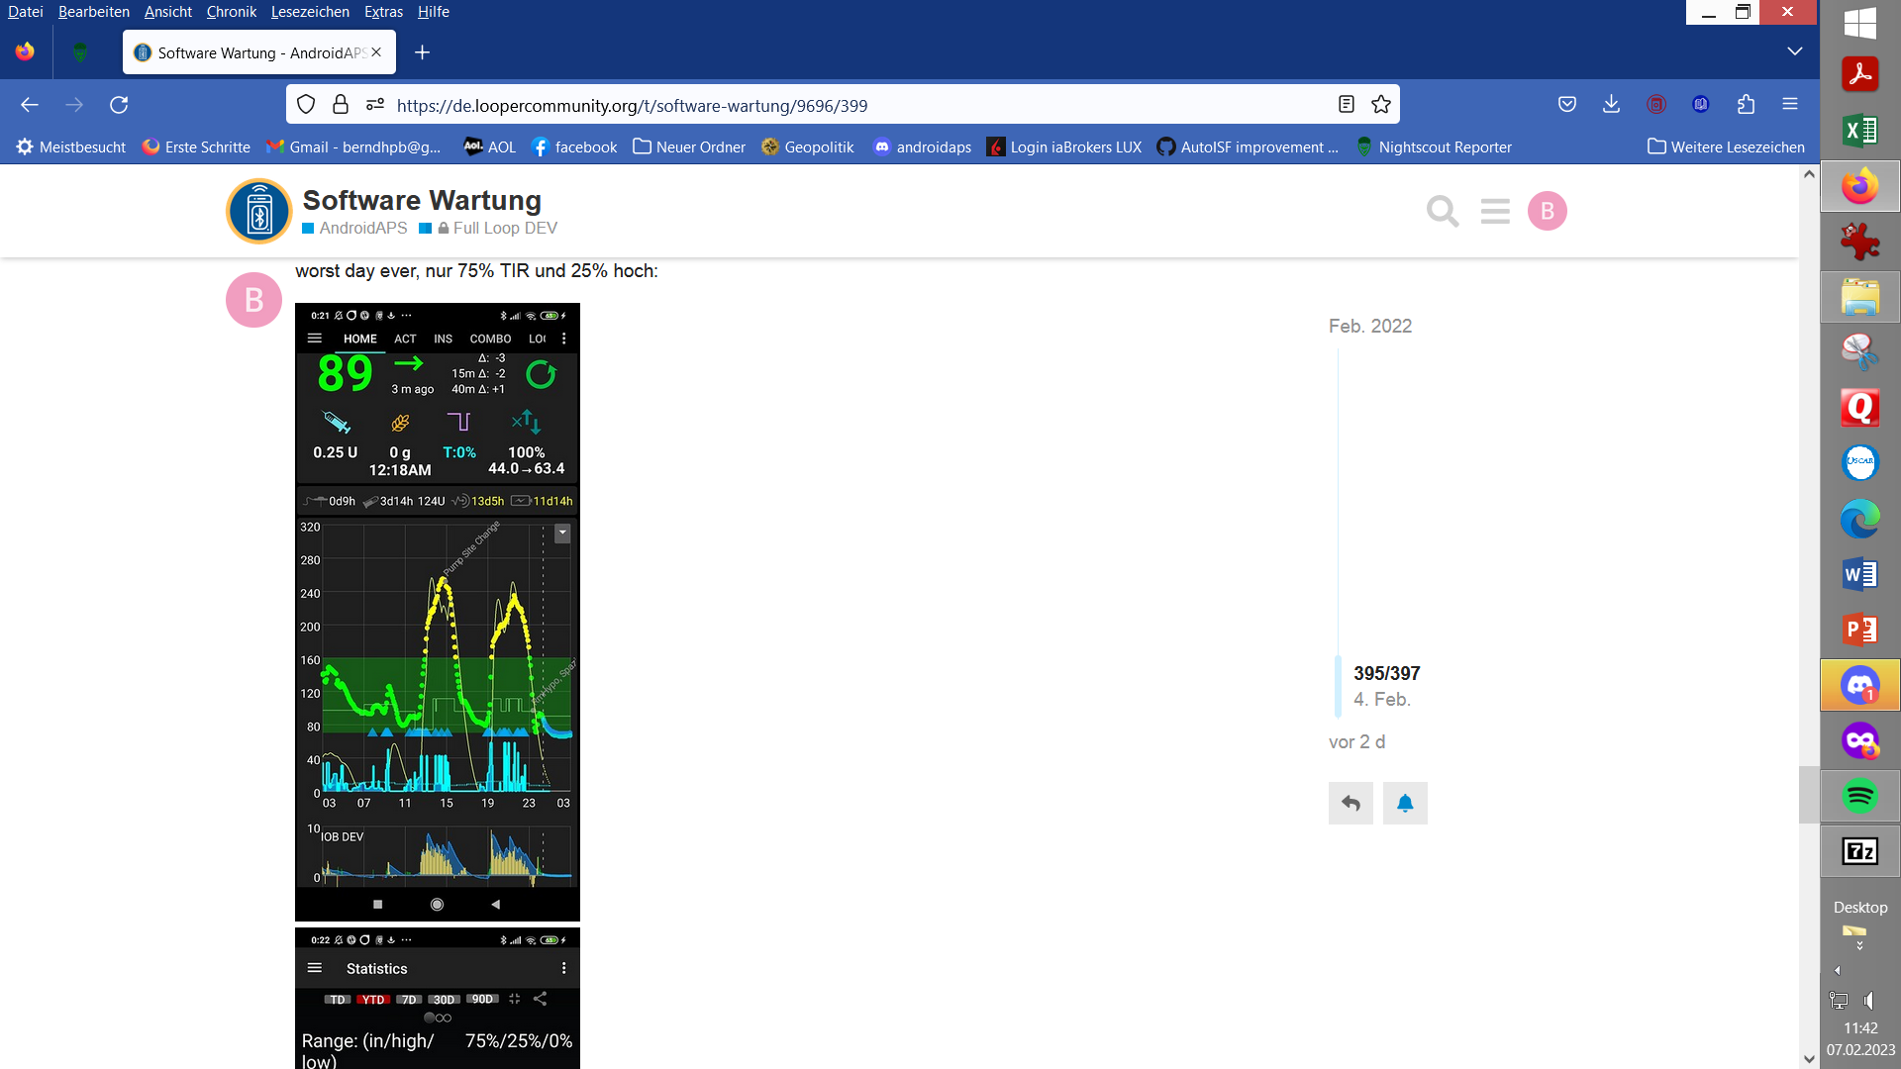

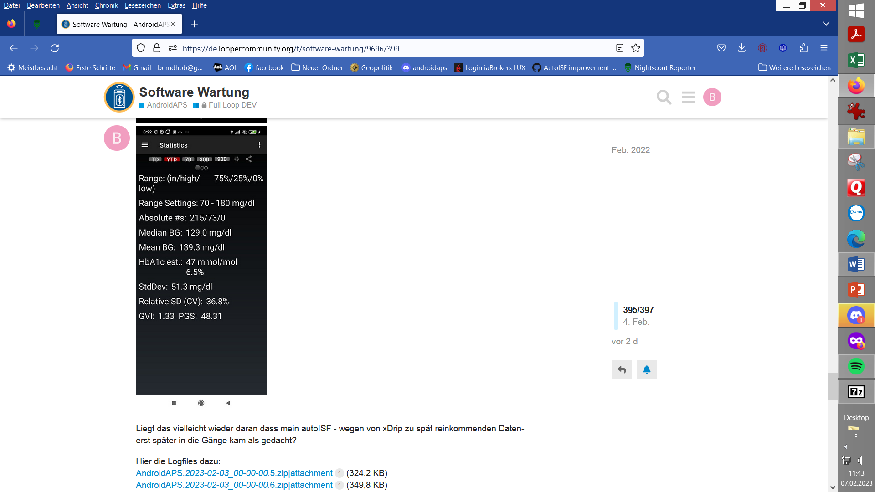

Das

Emulator Analysis of the First Peak ~ 12:30 – 15:00 central EU winter time

= Greenwich UTZ 11:30 – 16:00 (the Emulator uses universial time zone)

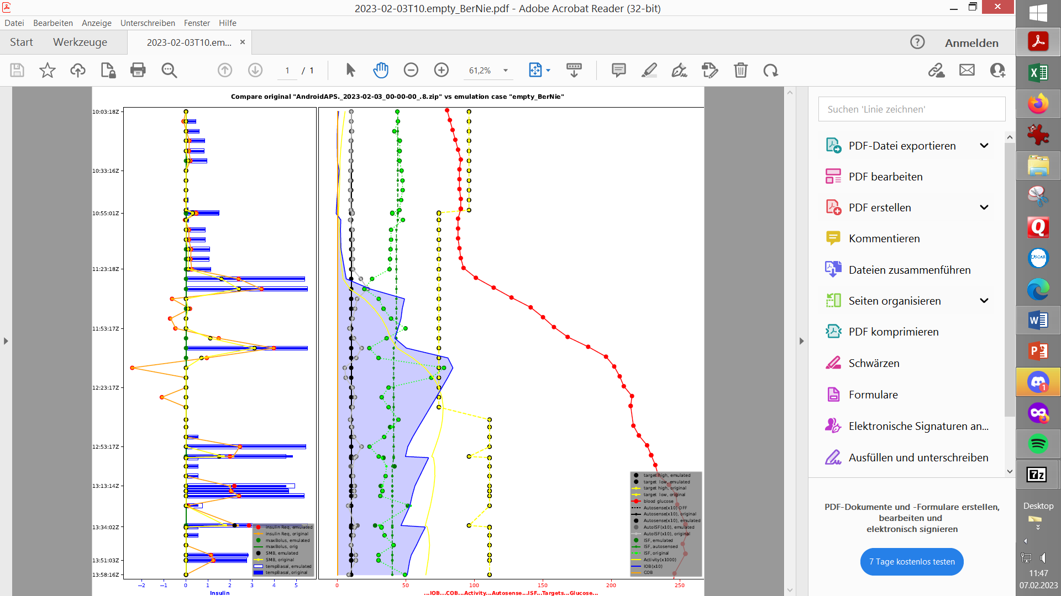

References to columns (letters) are for the table on the following page.

Column (E) and the red curve in the top right graph show the glucose progression. There was an EatingSoonTT of 74 (G) set until UTZ 12:33. Column (L) shows the iob. Values above my iobTH, for SMB shut-down, are highlighted in orange. Column (AH) shows the insulin_required, which is multiplied by the delivery_ratio (0.5...1) to the SMB size column (AL).

The insulinReq is no longer defined by the profile_ISF shown in (AF), but by the ISF of column (AE), which results from a calculation of the five autoISF components (columns Y - AC).

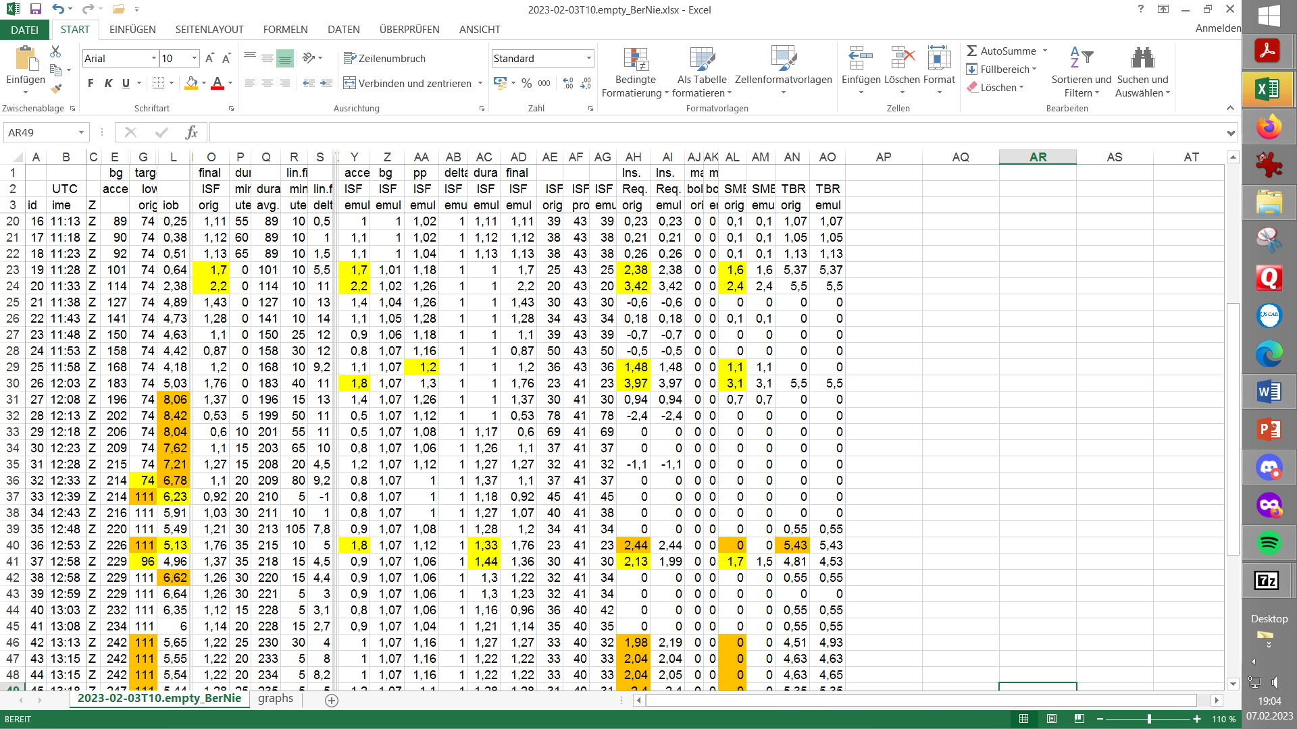

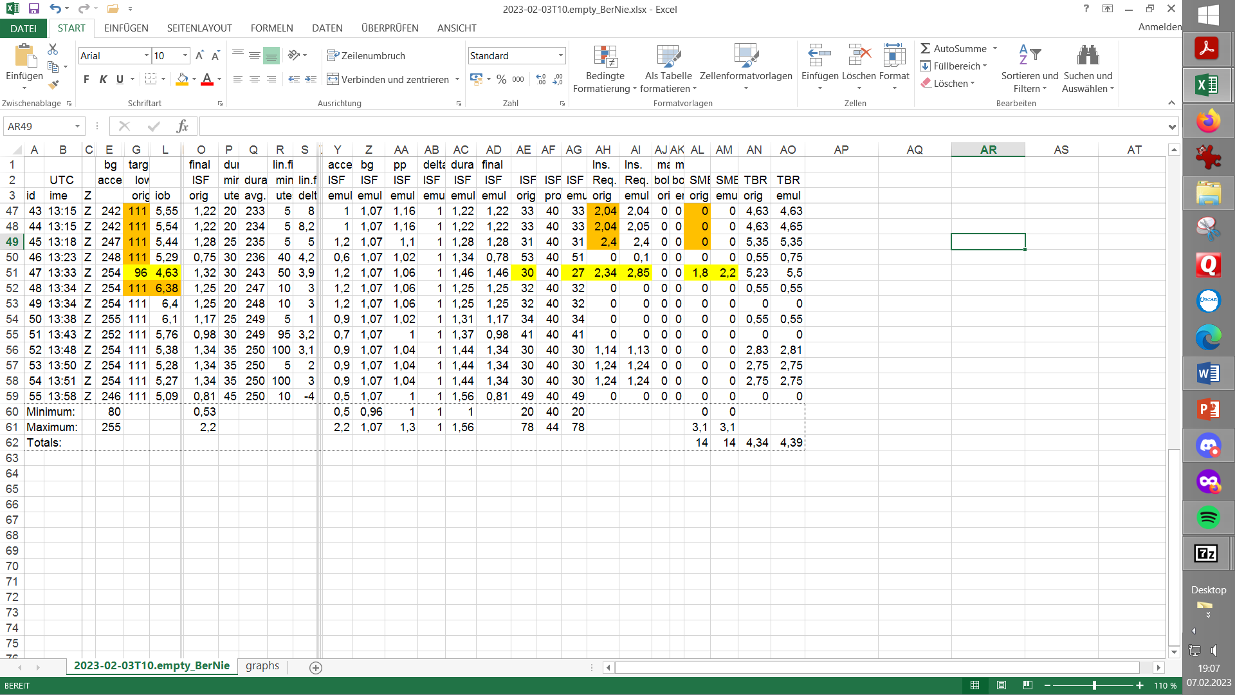

The problem can be seen that at 12:53 and 13:13-13:33 as well as 13:48-13:51, that an odd TT 111 switched SMBs off too early. A too low iobTH triggered the TT, therefore, some measures should be taken:

* **M1)** Set **iobTH** from 5.7 to 6.5 in my Automation

Note: In *autoISF versions before 3.0* iobTH had tob e set via a user-defined Automation.

To break the SMB blockade at TT 111 with high BG/high duraISF, the SMB shutdown, triggered by an odd TT, should not come so fast, and also dura_ISF is far from exhausted with weight=0.6. Tim Street had built the dura effect into OpenAps for an investigation and used it to run Scott Leibrand's backtest... and he thus found that 1.5 is the upper limit for dura_ISF_weight, above which hypos threaten. I don't quite trust this based on my experience so far, (and as my set SMB_delivery_ratio of ~ 0.8 (see „M3“) vs defalut 0.5 might mean another ~60% boost), hence "only":

* **M2)** Increase **duraISF_weight** carefully from 0.6 -> 0.8

Increases of weights can also be checked in the emulator. The only line for the VDF file for this would be e.g. to test M2): profile dura_ISF_weight 0.8 ### was 0.6.

In the table, the effects of each 5 minute calculation of SMBs * are then shown in column AM (i.vs. AL); the underlying insulinReq in column AI insulinReq (i.vs. AH); the ISF used in column AG (i.vs. AE).

*\* We can only ever see how ONE changed decision would affect the loop. However, this changed decision would alter the further course of the glucose curve, which is exactly the intention. You can not calculate, with the model, the overall resulting new glucose curve.*

At the points marked in yellow, in columns AH and AL, it can be seen that the SMB_delivery_ratio of 0.65 should be significantly increased, Therefore these actions could be taken:

* **M3)** Set **SMB_delivery_ratio** from 0.65-0.75 to 0.8 to 0.9

In many cases, shown in the yellow highlighted entries in column Y, a higher insulinReq and thus higher SMB requested would be achievable with higher bgAcceI_ISF_weight.

* **M4)** **bgAccel_ISF_weight** is tuned from 0.22 to 0.26. This increases insulin required up to +18%*

Emulator Analysis of the Second Peak~ 19:00 – 21:00 central EU winter time  
= Greenwich UTZ 18:00 – 20:00

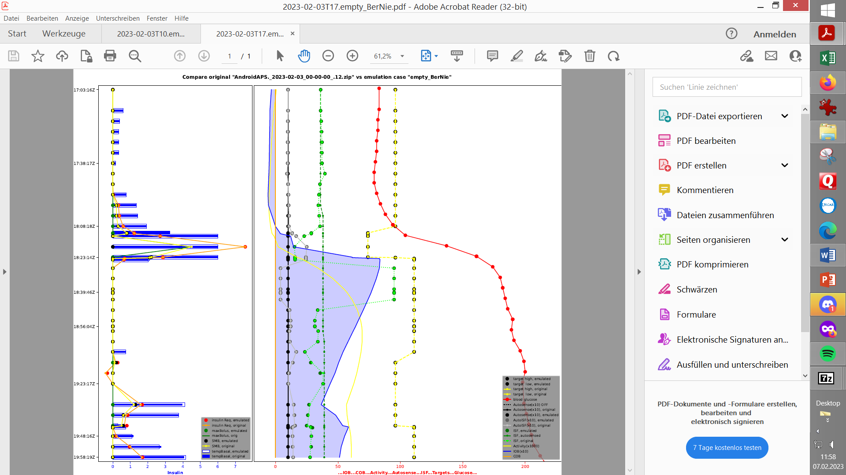

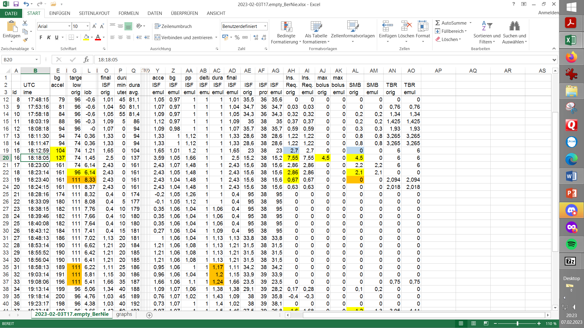

At 18:18, maxSMB size is 4.5 < insulin required; at 0.75 delivery ratio, as mentioned above in **M3)** 5.7 U (+1.2 U) would be asked for, but also ~ 25% bigger SMBs would have to be allowed, therefore some measures to take would be:

* **M5)** Allow 25%...33% larger SMB:change **SMB_range_extention from** 2.5 to 3.2
* **M6) autoISF_max** was already set quite high with 2.5, but to be able to ask for the "allowed" **M5)** SMB size, I increase **autoISF_max** by a similar percentage to 3.2

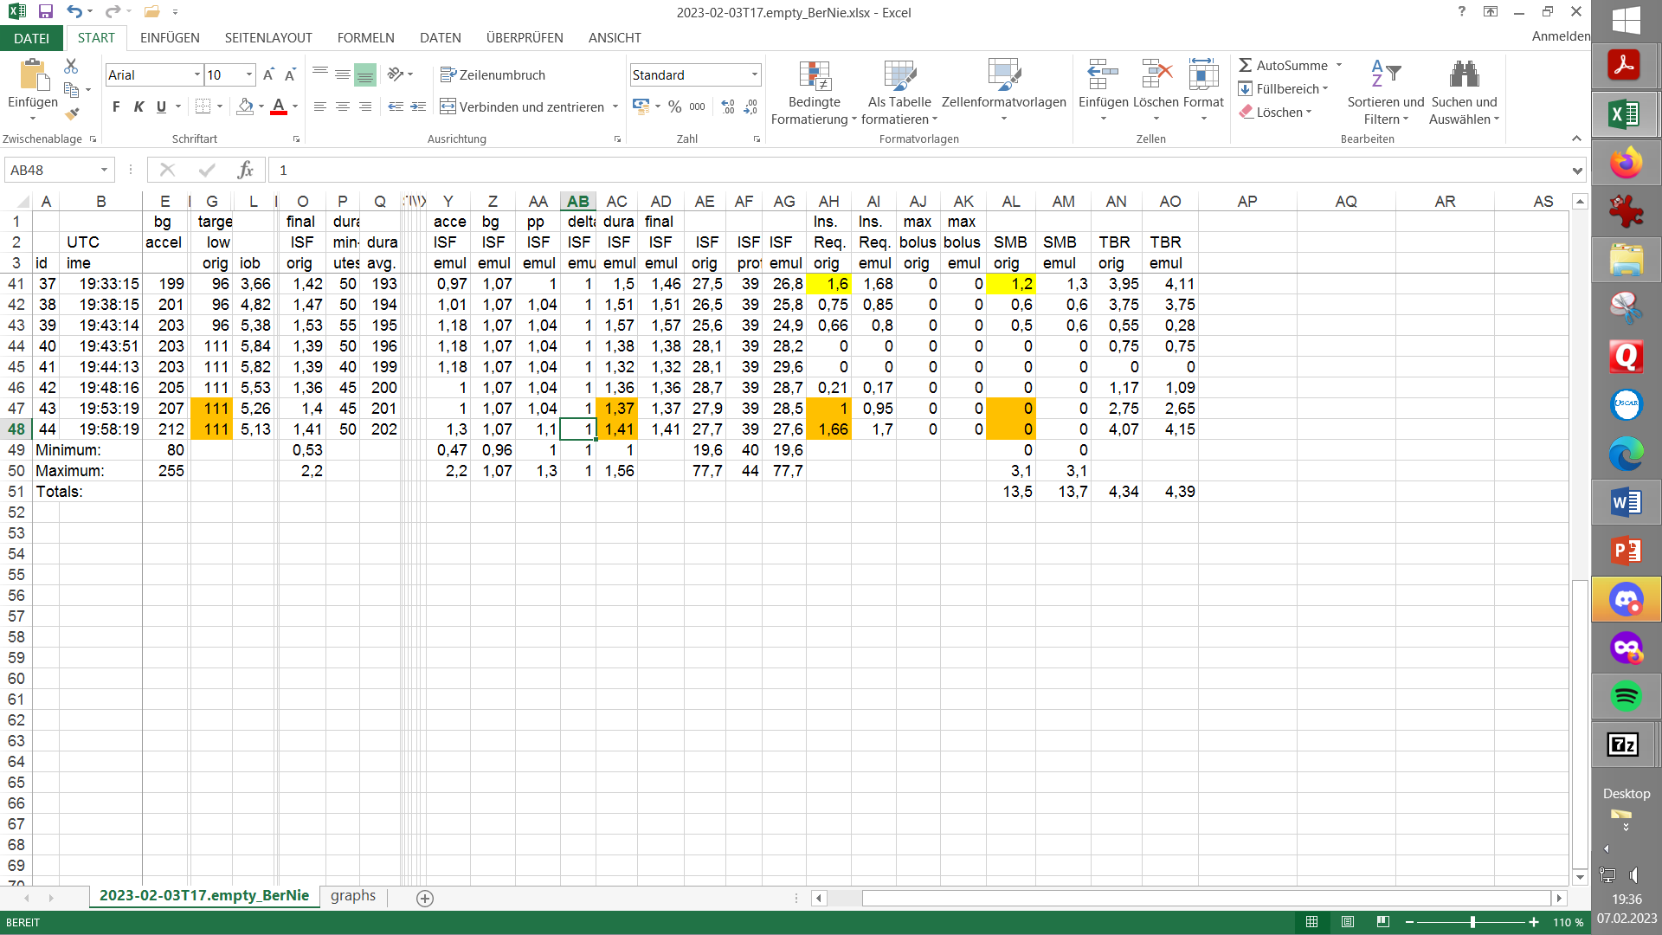

Also, in the evening, it shows in yellow fields in AH and AL columns, that a higher delivery ratio would bring improvements as described in **M3)**. Likewise, 19:53 shows again that stagnant high values at TT=111 produce the problem that no SMBs are allowed for correction and therefore the BG values remain elevated longer than necessary as described in **M2)**. On the other hand, at 18:58 - 19:08, the SMB blockade was harmless, because insulin required = 0. **M2)** would not have helped either.

At 18:12, we see a special case where a new CGM value received by the loop triggers a new loop run, however, the calculated **insulinReq**=2.7 did not trigger a SMB, because 3 minutes have not yet passed since the preceding SMB. Therefore some measures to be taken could be:

* **M7)** You could consider lowering the minimum 3 minutes between two SMBs in the source code

*I don't pursue this for now*, because the incident 18:12 seems rather exotic, and a shortening of the time span between 2 SMBs could lead to "tangling" of the loop with complications in delivery speeds; "restlessness" with overlapping information and actions. This is just an assumption by the author.

The actions **M1) - M6)** would definitely help to optimize the discussed day.

However, it's a bit daring to re-sharpen so many parameters at once.

Experience with the More Aggressive Settings

After 2-3 days with more aggressive settings, as described in **M1) - M6)** above, it was already clear that too often carbs must be eaten additionally to stay out of the hypo-zone. It just **didn't make sense to question everything** after a whole month at 94%TIR, just **because of one problem day** with 75% TIR!

The following dinner example shown in the screen shot on the next page shows the problems with the sharpened settings. It was initially well regulated until 22h. Then came influences of fat, some stress, and finally, "at an unfavorable moment" shortly after midnight, a dog walk.

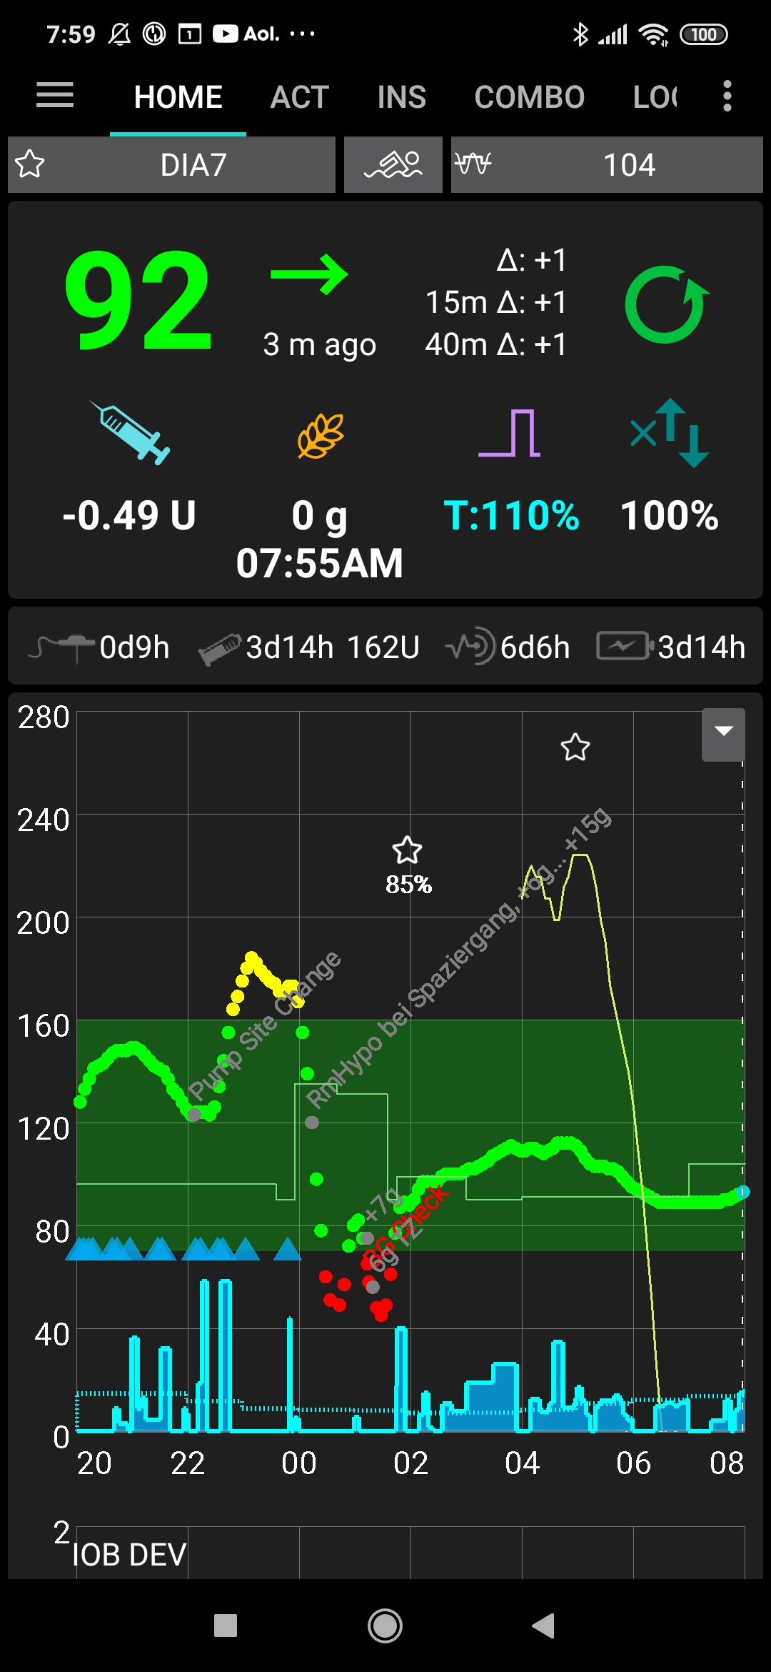

It took a whopping 34 g of CHO, and over an hour of waiting before bedtime, to be feel reasonably safe to go to sleep. Annoying low alarms did not help. So I had received 3 - 4 U too much insulin from the loop, which equates to 34 g / my profile IC, of which 1 - 2 U could be owed to reduced need, because of activity.

So I had to "row back" to settings that result in about 2 U lower iob before zero temping, and/or lower my iobTH a bit.

*Concerning 1-2 U reduction during activity, see section on Exercise*

Interim conclusion

The measures developed above are strongly attenuated for further testing as follows, respectively: By analyzing valid parameters in successful results obtained in previous months, I will decide on new settings, **N#)**, that are not as agressive as the ones described above in **M1) - M6)**

**N1)** set **iobTH** from 5.7 to 6.2 in my automation, rather than 6.5

Especially before activities, always pay attention to lowered iob threshold, as well as use sport button more often.

**N2)** increase **dura_ISF_weight** carefully 0.6 -> 0.8 (0.8)

**N3)** increase **SMB_delivery_ratio** from 0.65-0.75 to 0.8 (not 0.8 to 0.9, because I don't want to get much insulin, especially at high glucose levels)

**N4)** bgA**ccel_ISF_weight** becomes from 0.22 to 0.24 (not 0.26)

**N5)** **SMB_range_extention** increases from 2.5 -> 2.9 (not 3.2)

**N6)** **autoISF_max** increases from 2.5 -> 2.9 (not 3.2)

**Do not copy these settings!**

Options to consider

* A complete reset to the satisfactory settings that provided good results for months, before starting the analysis presented here, is one option.
* It could also well be that in further steps I have to rebalance the "job distribution" between **bgAccel_ISF_weight** and **pp_ISF_weight**, with a view also to **bgBrake_ISF_weight**. Especially **bgAccel_ISF_weight** could trigger too large SMBs, but I do not want to over-provide iob, because a relatively flat glucose curve could follow after the first small rise, attributed to a low carb meal or a snack.
* I could use the autoISF 3.0 enabled options to provide different settings for different clusters of meals (via Automation, or via FCL cockpit pre-set)